1711061518 – NguyenLeHoangDinh

**1.A network engineer is measuring the transfer of bits across the company backbone for a mission critical database application. The engineer notices that the network throughput appears lower than the bandwidth expected. Which three factors could influence the differences in throughput? (Choose three.) (4.1.3.3**

the amount of traffic that is currently crossing the network*

the type of traffic that is crossing the network*

the latency that is created by the number of network devices that the data is crossing*

**2.What function does pressing the Tab key have when entering a command in IOS?**

=> It completes the remainder of a partially typed word in a command

**3.On which switch interface would an administrator configure an IP address so that the switch can be managed remotely?**

=> VLAN 1

4.What unique address is embedded in an Ethernet NIC and used for communication on an Ethernet network?

=> MAC address

5.Which procedure is used to reduce the effect of crosstalk in copper cables?

=> twisting opposing circuit wire pairs together

6.A wireless host needs to request an IP address. What protocol would be used to process the request?

=> DHCP

7.What is the purpose of the command ping ::1?

=> It tests the internal configuration of an IPv6 host.

8.Why are port numbers included in the TCP header of a segment?

=> to enable a receiving host to forward the data to the appropriate application

9.What is a characteristic of the LLC sublayer? **(5.1.1.1)**

=> It places information in the frame allowing multiple Layer 3 protocols to use the same network interface and media.

10.What is one indication that a Windows computer did not receive an IPv4 address from a DHCP server?

=> The computer receives an IP address that starts with 169.254.

11.A company is expanding its business to other countries. All branch offices must remain connected to corporate headquarters at all times. Which network technology is required to support this requirement?

=> WAN

12.How does quality of service help a network support a wide range of applications and services?

=> by providing mechanisms to manage congested network traffic

13.Which statement is true about variable-length subnet masking?

=> The size of each subnet may be different, depending on requirements.

14.Which service provides dynamic global IPv6 addressing to end devices without using a server that keeps a record of available IPv6 addresses?

=> SLAAC

15. **Match the description with the associated IOS mode. (not all options are used.)**

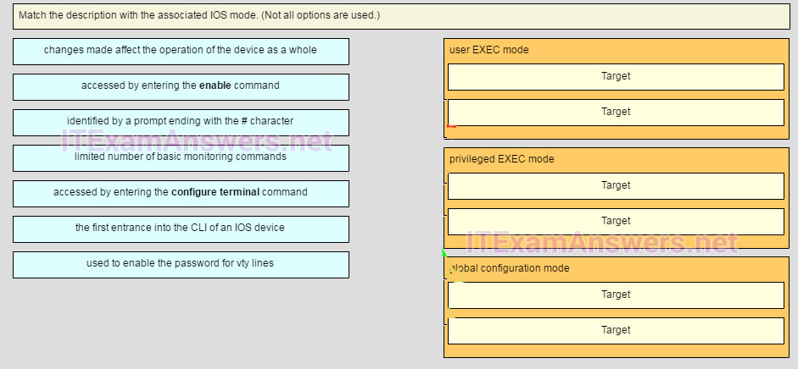

**user EXEC mode**  
limited number of basic monitoring commands  
the first entrance intro the CLI of an IOS device

**privileged EXEC mode**  
accessed by entering the enable command  
identified by a prompt ending with the # character

**global configuration mode**  
changes made affect the operation of the device as a whole  
accessed by entering the configure terminal command

16.Which two protocols operate at the highest layer of the TCP/IP protocol stack? (Choose two.)

=> DNS

POP

17.A network administrator wants to have the same subnet mask for three subnetworks at a small site. The site has the following networks and numbers of devices:

Subnetwork A: IP phones – 10 addresses

Subnetwork B: PCs – 8 addresses

Subnetwork C: Printers – 2 addresses

What single subnet mask would be appropriate to use for the three subnetworks?

=> 255.255.255.240*

18.Which firewall feature is used to ensure that packets coming into a network are legitimate responses to requests initiated from internal hosts?

=> stateful packet inspection

19.What are two ways that TCP uses the sequence numbers in a segment? (Choose two.)  **(9.1.2.2)**

=> to identify missing segments at the destination

to reassemble the segments at the remote location

20.At a minimum, which address is required on IPv6-enabled interfaces?

=> link-local

21.What will a host on an Ethernet network do if it receives a frame with a destination MAC address that does not match its own MAC address?

=> It will discard the frame.

22.What is an example of a top-level domain?

=> .com

23.Which subnet would include the address 192.168.1.96 as a usable host address?

=> 192.168.1.64/26

24.Refer to the exhibit. A network administrator is configuring access control to switch SW1. If the administrator has already logged into a Telnet session on the switch, which password is needed to access privileged EXEC mode? **(2.2.2.2)**

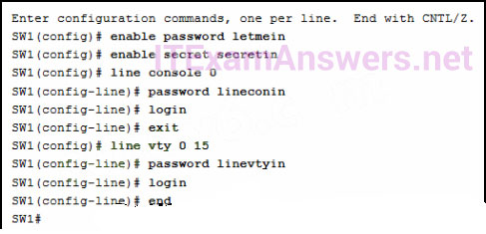

=> secretin*

25.What is the binary representation of 0xCA?

=> 11001010

26.What is one difference between the client-server and peer-to-peer network models?

=> Every device in a peer-to-peer network can function as a client or a server.

27.Which command can an administrator issue on a Cisco router to send debug messages to the vty lines?

=> terminal monitor

28.What method is used to manage contention-based access on a wireless network?

=> CSMA/CA

29.Which connection provides a secure CLI session with encryption to a Cisco switch?

=> an SSH connection

30.What are the three ranges of IP addresses that are reserved for internal private use? (Choose three.)

=> 10.0.0.0/8

172.16.0.0/12

192.168.0.0/16

31.A network engineer is analyzing reports from a recently performed network baseline. Which situation would depict a possible latency issue?

=> a change in the amount of RAM according to the show version output

32.Which two functions are primary functions of a router? (Choose two.)

=> packet forwarding

flow control

33.A home user is looking for an ISP connection that provides high speed digital transmission over regular phone lines. What ISP connection type should be used?

=> DSL

34.What are two characteristics of Ethernet MAC addresses? (Choose two.)

=> They are globally unique.

They are expressed as 12 hexadecimal digits.

35.What subnet mask is needed if an IPv4 network has 40 devices that need IP addresses and address space is not to be wasted?

=> 255.255.255.192

36.A network technician is attempting to configure an interface by entering the following command: SanJose(config)# ip address 192.168.2.1 255.255.255.0. The command is rejected by the device. What is the reason for this?

=> The command is being entered from the wrong mode of operation.

37.A network administrator is troubleshooting connectivity issues on a server. Using a tester, the administrator notices that the signals generated by the server NIC are distorted and not usable. In which layer of the OSI model is the error categorized?

=> physical layer

38.What is a characteristic of multicast messages?

=> They are sent to a select group of hosts.

39.What protocol is responsible for controlling the size of segments and the rate at which segments are exchanged between a web client and a web server?

=> TCP

40. 75

41.What layer is responsible for routing messages through an internetwork in the TCP/IP model?

=> internet

42.What are two characteristics shared by TCP and UDP? (Choose two.)

=> port numbering

use of checksum

43.Which statement accurately describes a TCP/IP encapsulation process when a PC is sending data to the network?

=> Segments are sent from the transport layer to the internet layer.

44.After making configuration changes on a Cisco switch, a network administrator issues a copy running-config startup-config command. What is the result of issuing this command?

=> The new configuration will be loaded if the switch is restarted.

45.What network service resolves the URL entered on a PC to the IP address of the destination server?

=> DNS

46.How many usable IP addresses are available on the 192.168.1.0/27 network?

=> 254

47.During the encapsulation process, what occurs at the data link layer for a PC connected to an Ethernet network?

=> The physical address is added.

48.Which switching method has the lowest level of latency?

=> fast-forward

49.What purpose does NAT64 serve in IPv6?

=> It converts IPv6 packets into IPv4 packets.

50.If a device receives an Ethernet frame of 60 bytes, what will it do?

Client/server

51.What are the three primary functions provided by Layer 2 data encapsulation? (Choose three.)

data link layer addressing

detection of errors through CRC calculations

delimiting groups of bits into frames

52.What are the three primary functions provided by Layer 2 data encapsulation? (Choose three.)

53.If a device receives an Ethernet frame of 60 bytes, what will it do?

Drop the frame.

54.Which two commands can be used on a Windows host to display the routing table? (Choose two.)

Tracert

Show ip route